View Fence Plants NO!
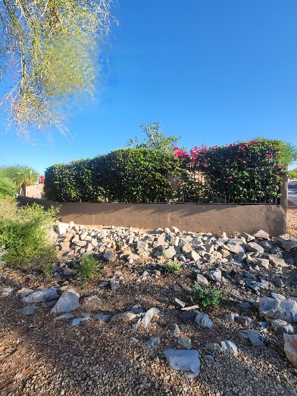
View Fence Chicken Wire – NO!
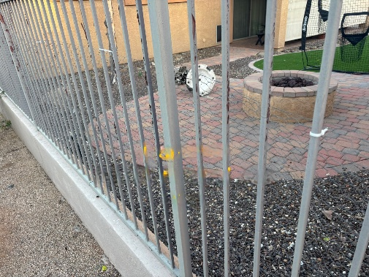

View Fence Chicken Wire & Plants NO!
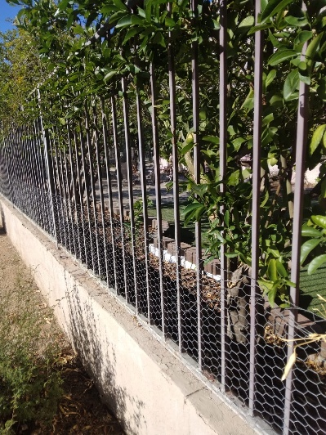
View Fence Plants NO!
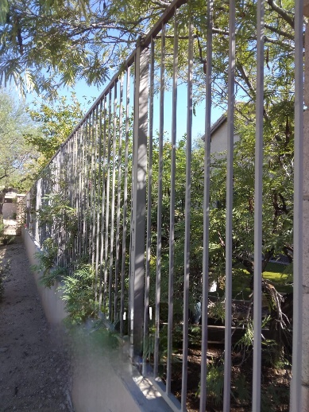
View Fence Plants & Lights NO!

Locked Gate – NO!
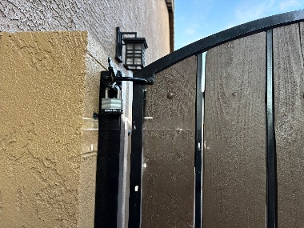
Unsecured Pets – NO!
